#34 –Mar 2017 (http://nzoac.nz/) 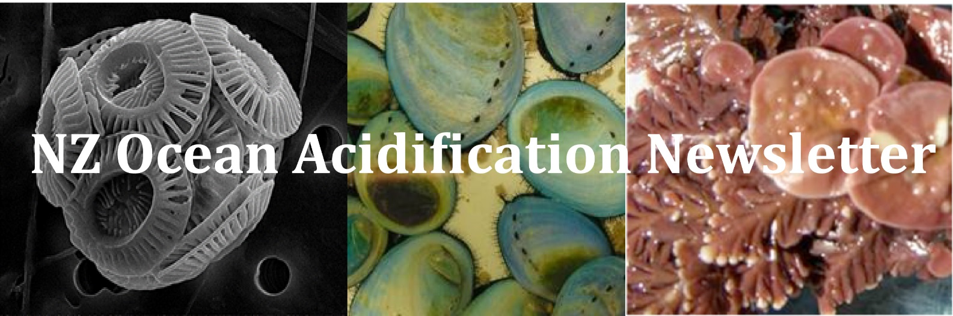
Community News
Following on from the NZOA Annual workshop there has been a lot of OA outreach work going on. Here are a few photos below. If you have any photos of field work or OA activities then please send them to us to include in the newsletters.
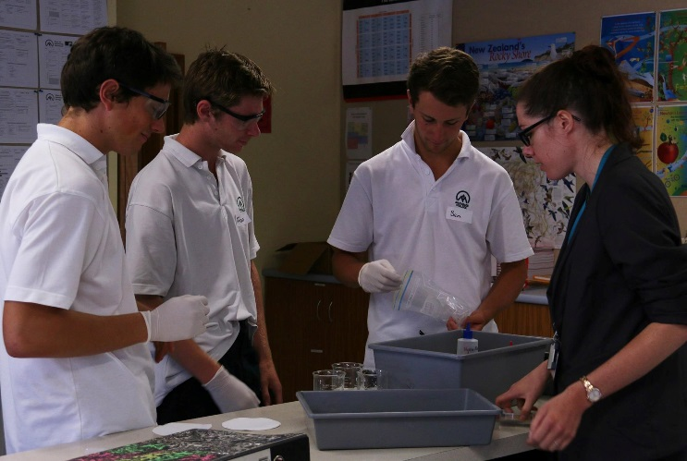
Some year 13 students from Mackenzie College being taught about OA using the new OA education resource that was launched at the workshop. (Photo credit Emily Frost).
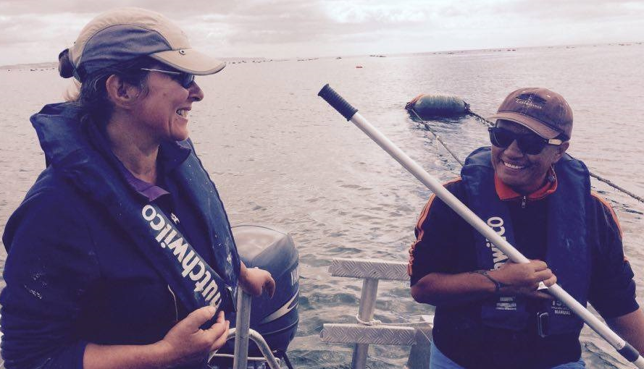
Veronika Meduna (NZ Geographic reporter) and Lucy Tukua (Iwi member) on the boat after helping with the maintenance and data retrieval of University of Auckland’s SeaFet (pH Sensor) and MicroCAT (temperature, salinity sensors) at a mussel farm in the Firth of Thames. Phil Evans holding a SeaFet in front of the iwi’s sacred mountain before re-deployment. (Photo credit Emily Frost).
Pacific Partnership on OA
Leaders from around the Pacific have joined in to tackle the issue of climate change specifically focusing on ocean acidification. Last week, was the opening of the New Zealand Pacific Partnership on Ocean Acidification (P.P.O.A) project and the Tokelau Project Inception Workshop at Taumeasina Island Resort. The New Zealand Pacific Partnership on Ocean Acidification (P.P.O.A) project is a collaborative effort between the Secretariat of the Pacific Regional Environment Programme (SPREP), the university of the South Pacific, and the Pacific Community which aims to build resilience to ocean acidification in Pacific Island communities and ecosystems, with financial support from the NZ Ministry of Foreign Affairs and Trade and the Government of Monaco. Deputy Director General of S.P.R.E.P. Roger Cornforth, stressed the importance in taking immediate action against climate change for the Pacific Islands. He said, “The Pacific Islands are at the frontlines of climate change, and their peoples are dedicated climate change warriors whose voices have been active in shaping global climate change policy and action. The Pacific Islands led the fight during COP 21 and actively worked to have the goal of limiting global warming to 1.5 degrees C included in the Paris Agreement. The impacts of climate change on our oceans have been largely overlooked and action has been lacking. Given our high dependence and intimate relationship with the ocean we already lead the world in marine management and conservation, and we are poised to lead the world on managing the impacts of climate change on our oceans.In addition to sea level rise, climate change is causing our oceans to warm and become more acidic, both of which are detrimental to. Globally we have already lost 50% of our coral reefs and their associated fisheries and ecosystem services due to local anthropogenic stressors such as destructive fishing practices and pollution. By 2050, under business-as-usual practices, the world will likely lose 90% of its coral reefs. The risks posed by this are highest for the atoll nations such as Tokelau, where the reef is your home and basis of your livelihoods.” The Ulu o Tokelau (equivalent to Head of State) Faipule Siopili Perez stated “I believe resilience and innovation is based on the amalgamation of traditional knowledge and modern technology, both rooted in science, can only bring out the best results for nature and our people.”
GESAMP Working Group 38 on Impact of Ocean Acidification on Fluxes of non-CO2 Climate-Active Species
Cliff Law was invited to participate in the 38th Working Group meeting of the Joint Group of Experts on the Scientific Aspects of Marine Environmental Protection (GESAMP), a body that advises the UN on scientific aspects of marine environmental protection. The meeting, held at the University of East Anglia (Norwich, UK) at the start of March, focussed on the Impact of Ocean Acidification on Fluxes of non-CO2 Climate-Active Species. Data was presented for a range of trace gases from laboratory and mesocosm experiments. The most evident result was the lack of research in this area, with sufficient data available for only one trace gas, Dimethlysulphide (DMS), to draw any tentative conclusions on the impact of OA. Nevertheless, an output of the workshop will be some summary papers, that identify the potential feedbacks on climate via marine trace gas emissions, as well as recommendations for experimental & observational studies.
Selection of reports, theses and recent papers from the SW Pacific
Ocean acidification changes abiotic processes but not biotic processes in coral reef sediments. In coral reefs, sediments play a crucial role in element cycling by contributing to primary production and the remineralization of organic matter. We studied how future ocean acidification (OA) will affect biotic and abiotic processes in sediments from two coral reefs of the Great Barrier Reef, Australia. This was investigated in the laboratory under conditions where water-sediment exchange was dominated by molecular diffusion (Magnetic Island) or by porewater advection (Davies Reef). OA conditions (+ΔpCO2: 170–900 µatm, -ΔpH: 0.1–0.4) did not affect photosynthesis, aerobic and anaerobic organic matter remineralization and growth of microphytobenthos. However, microsensor measurements showed that OA conditions reduced the porewater pH. Under diffusive conditions these changes were limited to the upper sediment layers. In contrast, advective conditions caused a deeper penetration of low pH water into the sediment resulting in an earlier pH buffering by dissolution of calcium carbonate (CaCO₃). This increased the dissolution of Davis Reef sediments turning them from net precipitating (-0.8 g CaCO₃ m⁻² d⁻¹) under ambient to net dissolving (1 g CaCO₃ m⁻² d⁻¹) under OA conditions. Comparisons with in-situ studies on other reef sediments show that our dissolution rates are reasonable estimates for field settings. We estimate that enhanced dissolution due to OA will only have a minor effect on net ecosystem calcification of the Davies Reef flat (< 4%). However, it could decrease recent sediment accumulation rates in the lagoon by up to 31% (by 0.2–0.4 mm year-1), reducing valuable reef space. Furthermore, our results indicate that high-magnesium calcite is predominantly dissolving in the studied sediments and a drastic reduction in this mineral can be expected on Davis Reef lagoon in the near future, leaving sediments of an altered mineral composition. This study demonstrates that biotic sediment processes will likely not directly be affected by OA. Ensuing indirect effects of OA-induced sediment dissolution on biotic processes are discussed. Fink A., et al., 2017. Frontiers in Marine Science 4:73. Article.
Rapid emergence of climate change in environmental drivers of marine ecosystems. Climate change is expected to modify ecological responses in the ocean, with the potential for important effects on the ecosystem services provided to humankind. Here we address the question of how rapidly multiple drivers of marine ecosystem change develop in the future ocean. By analysing an ensemble of models we find that, within the next 15 years, the climate change-driven trends in multiple ecosystem drivers emerge from the background of natural variability in 55% of the ocean and propagate rapidly to encompass 86% of the ocean by 2050 under a ‘business-as-usual’ scenario. However, we also demonstrate that the exposure of marine ecosystems to climate change-induced stress can be drastically reduced via climate mitigation measures; with mitigation, the proportion of ocean susceptible to multiple drivers within the next 15 years is reduced to 34%. Mitigation slows the pace at which multiple drivers emerge, allowing an additional 20 years for adaptation in marine ecological and socio-economic systems alike. Henson S. A., et al., 2017. Nature Communications 8:14682. Article.
Bioerosion: the other ocean acidification problem: Bioerosion of calcium carbonate is the natural counterpart of biogenic calcification. Both are affected by ocean acidification (OA). We summarize definitions and concepts in bioerosion research and knowledge in the context of OA, providing case examples and meta-analyses. Chemically mediated bioerosion relies on energy demanding, biologically controlled undersaturation or acid regulation and increases with simulated OA, as does passive dissolution. Through substrate weakening both processes can indirectly enhance mechanical bioerosion, which is not directly affected by OA. The low attention and expert knowledge on bioerosion produced some ambiguous views and approaches, and limitations to experimental studies restricted opportunities to generalize. Comparability of various bioerosion and calcification rates remains difficult. Physiological responses of bioeroders or interactions of environmental factors are insufficiently studied. We stress the importance to foster and advance high quality bioerosion research as global trends suggest the following: (i) growing environmental change (eutrophication, coral mortality, OA) is expected to elevate bioerosion in the near future; (ii) changes harmful to calcifiers may not be as severe for bioeroders (e.g. warming); and (iii) factors facilitating bioerosion often reduce calcification rates (e.g. OA). The combined result means that the natural process bioerosion has itself become a “stress factor” for reef health and resilience. Schönberg C. H. L., et al.,. Contribution to the Themed Issue: ‘Ocean Acidification’. ICES Journal of Marine Science. Article.
Calculating surface ocean pCO2 from biogeochemical Argo floats equipped with pH: an uncertainty analysis. More than 74 biogeochemical profiling floats that measure water column pH, oxygen, nitrate, fluorescence, and backscattering at 10-day intervals have been deployed throughout the Southern Ocean. Calculating the surface ocean partial pressure of carbon dioxide (pCO₂sw) from float pH has uncertainty contributions from the pH sensor, the alkalinity estimate, and carbonate system equilibrium constants, resulting in a relative standard uncertainty in pCO₂sw of 2.4% (or 10 µatm at pCO2sw of 400 µatm). The calculated pCO₂sw from several floats spanning a range of oceanographic regimes are compared to existing climatologies. In some locations, such as the Subantarctic zone, the float data closely match the climatologies, but in the Polar Antarctic Zone significantly higher pCO₂sw are calculated in the wintertime implying a greater air-sea CO₂ efflux estimate. Our results based on four representative floats suggest that despite their uncertainty relative to direct measurements the float data can be used to improve estimates for air-sea carbon flux, as well as to increase knowledge of spatial, seasonal, and interannual variability in this flux. Williams N. L., et al., Global Biogeochemical Cycles. Article (subscription required).
An evaluation of ISFET sensors for coastal pH monitoring applications. The accuracy and precision of ion sensitive field effect transistor (ISFET) pH sensors have been well documented, but primarily by ocean chemistry specialists employing the technology at single locations. Here we examine their performance in a network context through comparison to discrete measurements of pH, using different configurations of the Honeywell DuraFET pH sensor deployed in six coastal settings by operators with a range of experience. Experience of the operator had the largest effect on performance. The average difference between discrete and ISFET pH was 0.005 pH units, but ranged from −0.030 to 0.083 among operators, with more experienced operators within ±0.02 pH units of the discrete measurement. In addition, experienced operators achieved a narrower range of variance in difference between discrete bottle measurements and ISFET sensor readings compared to novice operators and novice operators had a higher proportion of data failing quality control screening. There were no statistically significant differences in data uncertainty associated with sensor manufacturer or deployment environment (pier-mounted, flowthrough system, and buoy-mounted). The variation we observed among operators highlights the necessity of best practices and training when instruments are to be used in a network where comparison across data streams is desired. However, while opportunities remain for improving the performance of the ISFET sensors when deployed by less experienced operators, the uncertainty associated with their deployment and validation was several-fold less than the observed natural temporal variability in pH, demonstrating the utility of these sensors in tracking local changes in acidification. McLaughlin K., et al., 2017. Regional Studies in Marine Science 12:11–18. Article (subscription required).
Early life behaviour and sensory ecology of predatory fish under climate change and ocean acidification. The early life cycle of a fish species is presumed to be the most vulnerable to abiotic change. Their successful development and growth is key to sustaining and connecting existing populations and dispersal to new habitats. Larvae and juvenile fish have to progressively develop and fine tune their behavioural and sensory capabilities in order to successfully hunt and or forage for prey, avoid larger predators and find suitable habitat to reach maturity and reproduce. Their sensory capabilities typically involve multiple senses including, vision, olfaction and audition. Ocean warming and acidification alter the physiological performance and behaviour of many small bodied fish, however, the potential interactive effects of these stressors on large predatory fish has not been explored fully and may act synergistically or antagonistically. Predatory fish can have large effects on trophically-structured systems. The potential for altered predatory function through alterations in their metabolism as a result of temperature and behaviour from ocean acidification may not only affect their hunting ability but also the communities in which their prey live. In this thesis, I show that the combination of ocean warming with acidification can alter the metabolic function and hunting behaviour of a predatory shark leading to considerable reductions in growth rates. Laboratory experiments revealed faster embryonic development under elevated temperature, however elevated temperature and CO₂ had detrimental impacts on sharks by increasing energetic demands. Subsequent mesocosm experiments showed reductions in growth rates under elevated CO₂ either alone or in combination with elevated temperatures, where their metabolic efficiency was decreased and their ability to locate food through olfaction was reduced. Additionally, while elevated temperature increased the motivational drive to locate prey, elevated CO2 negated chemical and visual behavioural responses that enable effective hunting. I also found that ocean acidification alone altered the physicochemical sensing in a predatory teleost fish (Barramundi) such that cues for temperature and salinity were inhibited by reduced pH. This thesis reveals a more complex reality for predators where the combination of elevated temperature and CO₂ reduces their ability to hunt effectively leading to smaller sharks, ultimately reduces their ability to exert strong top-down control over food webs. Furthermore, alterations to their perception and evaluation of environmental cues during the critical phase of dispersal have implications for ensuing recruitment and population replenishment. Alterations such as the ones brought about by ocean acidification and increased temperature far reaching consequences, not just for the individual predator population’s sustainability, but also the ecosystem food webs which they inhabit. Pistevos J. C. A., 2016. PhD thesis, University of Adelaide, 164 p. Thesis.
Species-specific responses to ocean acidification should account for local adaptation and adaptive plasticity. Global stressors, such as ocean acidification, constitute a rapidly emerging and significant problem for marine organisms, ecosystem functioning and services. The coastal ecosystems of the Humboldt Current System (HCS) off Chile harbour a broad physical–chemical latitudinal and temporal gradient with considerable patchiness in local oceanographic conditions. This heterogeneity may, in turn, modulate the specific tolerances of organisms to climate stress in species with populations distributed along this environmental gradient. Negative response ratios are observed in species models (mussels, gastropods and planktonic copepods) exposed to changes in the partial pressure of CO₂ (pCO₂) far from the average and extreme pCO₂ levels experienced in their native habitats. This variability in response between populations reveals the potential role of local adaptation and/or adaptive phenotypic plasticity in increasing resilience of species to environmental change. The growing use of standard ocean acidification scenarios and treatment levels in experimental protocols brings with it a danger that inter-population differences are confounded by the varying environmental conditions naturally experienced by different populations. Here, we propose the use of a simple index taking into account the natural pCO₂ variability, for a better interpretation of the potential consequences of ocean acidification on species inhabiting variable coastal ecosystems. Using scenarios that take into account the natural variability will allow understanding of the limits to plasticity across organismal traits, populations and species. Vargas C. A., et al., 2017. Nature Ecology & Evolution 1:0084. Article.
Global variability and changes in ocean total alkalinity from Aquarius satellite data. This work demonstrates how large-scale Aquarius satellite salinity data have provided an unprecedented opportunity when combined with total alkalinity (TA) equations as a function of salinity and temperature to examine global changes in the CO₂ system. Alkalinity is a gauge on the ability of seawater to neutralize acids. TA correlates strongly with salinity. Spatial variability in alkalinity and salinity exceed temporal variability. Northern Hemisphere has more spatial variability in TA and salinity, while less variability in Southern Ocean TA is due to less salinity variability and upwelling of waters enriched in alkalinity. For the first time it is shown that TA in subtropical regions has increased as compared with climatological data; this is reflective of large-scale changes in the global water cycle. Thus, as temperature and salinity increase in subtropical regions, the resultant increase in TA and ocean acidification is reinforcing that from oceanic uptake of atmospheric CO₂. Fine R. A., et al., 2017. Geophysical Research Letters 44:261–267. Article (subscription required).
Environmental controls on the growth, photosynthetic and calcification rates of a Southern Hemisphere strain of the coccolithophore Emiliania huxleyi. We conducted a series of diagnostic fitness response experiments on the coccolithophore, Emiliania huxleyi, isolated from the Subtropical Convergence east of New Zealand. Dose response curves (i.e., physiological rate vs. environmental driver) were constructed for growth, photosynthetic, and calcification rates of E. huxleyi relative to each of five environmental drivers (nitrate concentration, phosphate concentration, irradiance, temperature, and pCO₂). The relative importance of each environmental driver on E. huxleyi rate processes was then ranked using a semi-quantitative approach by comparing the percentage change caused by each environmental driver on the measured physiological metrics under the projected conditions for the year 2100, relative to those for the present day, in the Subtropical Convergence. The results reveal that the projected future decrease in nitrate concentration (33%) played the most important role in controlling the growth, photosynthetic and calcification rates of E. huxleyi, whereas raising pCO₂ to 75 Pa (750 ppm) decreased the calcification: photosynthesis ratios to the greatest degree. These findings reveal that other environmental drivers may be equally or more influential than CO₂ in regulating the physiological responses of E. huxleyi, and provide new diagnostic information to better understand how this ecologically important species will respond to the projected future changes to multiple environmental drivers. Feng Y., et al., 2017. Limnology and Oceanography 62:519–540. Article.
Factors affecting coral recruitment and calcium carbonate accretion rates on a Central Pacific coral reef. The aim of this thesis was to determine how biophysical forcing factors affect coral recruitment, calcification and bioerosion on a pristine coral reef. I used artificial settlement tiles to measure coral recruitment and CaCO3 accretion at ten sites (four on the fore reef, four on the Western Reef Terrace and two at the Entrance Channel) at Palmyra Atoll. Fungia skeletons and pieces of dead coral rock were used to measure bioerosion rates, which were combined with the CaCO3 accretion rates to obtain a net CaCO3 budget of the reef substratum. Interactions between coral recruits and other benthic organisms on the settlement tiles were recorded to determine the settlement preferences and competitive strength of coral recruits. The settlement preference of Pocillopora damicornis for divots shaped like steephead and bumphead parrotfish bites marks was determined by adding P. damicornis larvae to a container with a settlement tile with the aforementioned divots.I found that coral recruitment and CaCO3 accretion are influenced by biophysical forcing factors. Most pocilloporids likely recruit close to their parents while the origin of poritid larvae is much more distant. Pocilloporid recruitment rates were also significantly correlated with the successional stage of the benthic community on the settlement tiles, especially the cover of biofilm and bryozoa. Biofilm and crustose coralline algae (CCA) were preferred as settlement substrata by coral larvae, however both pocilloporids and poritids settled on a large number of different benthic substrata. P. damicornis larvae showed a significant settlement preference for divots shaped like parrotfish bite marks over a flat settlement surface. Coral recruits were good competitors against encrusting algae but were often outcompeted by filamentous and upright algae. Settlement tiles were almost entirely colonised by benthic organisms within three to twelve months of deployment. The mass of CaCO3 deposited onto the settlement tiles negatively correlated with herbivore grazing pressure on the benthic community. Bioerosion rates within pieces of coral (internal bioerosion) increased over time but overall bioerosion rates (internal and external) rarely exceeded CaCO3 deposition by CCA.My results show how variability in biophysical forcing factors leads to natural variation in coral recruitment and CaCO3 accretion. This thesis highlights the importance of measuring herbivore grazing, CCA and turf algae cover to gain a better understanding of reef resilience. I conclude that models constructed for Caribbean reefs may not be suited to predict resilience in Pacific reefs and that within the Pacific, two different kinds of resilience models need to be constructed, one for human-inhabited coral reefs and one for uninhabited coral reefs. Elmer F., 2017. PhD thesis, Victoria University of Wellington, 250 p. Thesis.
Effects of CO2 concentration on a late summer surface sea ice community. Annual fast ice at Scott Base (Antarctica) in late summer contained a high biomass surface community of mixed phytoflagellates, dominated by the dinoflagellate, Polarella glacialis. At this time of the year, ice temperatures rise close to melting point and salinities drop to less than 20. At the same time, pH levels can rise above 9 and nutrients can become limiting. In January 2014, the sea ice microbial community from the top 30 cm of the ice was exposed to a gradient of pH and CO2 (5 treatments) that ranged from 8.87 to 7.12 and 5–215 µmol CO2 kg−1, respectively, and incubated in situ. While growth rates were reduced at the highest and lowest pH, the differences were not significant. Likewise, there were no significant differences in maximum quantum yield of PSII (Fv/Fm) or relative maximum electron transfer rates (rETRmax) among treatments. In a parallel experiment, a CO2 gradient of 26–230 µmol CO2 kg−1 (5 treatments) was tested, keeping pH constant. In this experiment, growth rates increased by approximately 40% with increasing CO2, although differences among treatments were not significant.. As in the previous experiment, there was no significant response in Fv/Fm or rETRmax. A synchronous grazing dilution experiment found grazing rates to be inconclusive These results suggest that the summer sea ice brine communities were not limited by in situ CO2 concentrations and were not adversely affected by pH values down to 7.1. McMinn A., et al., 2017 Marine Biology 164:87. Article (subscription required).
Biological responses of sharks to ocean acidification. Sharks play a key role in the structure of marine food webs, but are facing major threats due to overfishing and habitat degradation. Although sharks are also assumed to be at relatively high risk from climate change due to a low intrinsic rate of population growth and slow rates of evolution, ocean acidification (OA) has not, until recently, been considered a direct threat. New studies have been evaluating the potential effects of end-of-century elevated CO2 levels on sharks and their relatives’ early development, physiology and behaviour. Here, we review those findings and use a meta-analysis approach to quantify the overall direction and magnitude of biological responses to OA in the species of sharks that have been investigated to date. While embryo survival and development time are mostly unaffected by elevated CO2, there are clear effects on body condition, growth, aerobic potential and behaviour (e.g. lateralization, hunting and prey detection). Furthermore, studies to date suggest that the effects of OA could be as substantial as those due to warming in some species. A major limitation is that all past studies have involved relatively sedentary, benthic sharks that are capable of buccal ventilation—no studies have investigated pelagic sharks that depend on ram ventilation. Future research should focus on species with different life strategies (e.g. pelagic, ram ventilators), climate zones (e.g. polar regions), habitats (e.g. open ocean), and distinct phases of ontogeny in order to fully predict how OA and climate change will impact higher-order predators and therefore marine ecosystem dynamics.Rosa R., et al., 2017. Biology Letters 13(3). Article (subscription required).
Coralline algae elevate pH at the site of calcification under ocean acidification Coralline algae provide important ecosystem services but are susceptible to the impacts of ocean acidification. However, the mechanisms are uncertain, and the magnitude is species specific. Here, we assess whether species-specific responses to ocean acidification of coralline algae are related to differences in pH at the site of calcification within the calcifying fluid/medium (pHcf) using δ¹¹B as a proxy. Declines in δ¹¹B for all three species are consistent with shifts in δ¹¹B expected if B(OH)₄⁻ was incorporated during precipitation. In particular, the δ¹¹B ratio in Amphiroa anceps was too low to allow for reasonable pHcf values if B(OH)₃ rather than B(OH)₄⁻ was directly incorporated from the calcifying fluid. This points towards δ¹¹B being a reliable proxy for pHcf for coralline algal calcite and that if B(OH)₃ is present in detectable proportions, it can be attributed to secondary postincorporation transformation of B(OH)₄⁻. We thus show that pHcf is elevated during calcification and that the extent is species specific. The net calcification of two species of coralline algae (Sporolithon durum, and Amphiroa anceps) declined under elevated CO2, as did their pHcf. Neogoniolithon sp. had the highest pHcf, and most constant calcification rates, with the decrease in pHcf being ¼ that of seawater pH in the treatments, demonstrating a control of coralline algae on carbonate chemistry at their site of calcification. The discovery that coralline algae upregulate pHcf under ocean acidification is physiologically important and should be included in future models involving calcification. Cornwall, C.E., et al., 2017. Glob Change Biol. 2017;00:1–12. https://doi.org/10.1111/gcb.13673.

Upcoming meetings
New Zealand Marine Sciences Society Annual Conference

Mahi Ngātahi: Working together for better management into the future
4-6 July 2017, University of Canterbury, Christchurch
VONDA CUMMINGS WILL BE ONE OF THE KEYNOTE SPEAKERS AT THIS CONFERENCE!
www.nzmss2017.org/ or nzmss.org/events

Climate Change and High CO2 Effects on Fishes: Moving from Individual to Community Level Effects,
10th Indo-Pacific Fish Conference, 2-6 October 2017, Tahiti, French Polynesia
Deadline for abstract submission: 22 July 2017!
Convenors: Ivan Nagelkerken, Philip Munday, Colin Brauner & Marc Metian
Description: We have entered an era of increasing uncertainty about the effect of human activities on the function and services of marine and freshwater ecosystems. Although research on climate change and acidification of ocean and more recently freshwater systems has rapidly accelerated, there has been a primary emphasis on single stressor, single habitat, single species, single life stage, and short-term experiments. This has led to an incomplete view of how multiple global stressors may truly affect fish populations and communities over the longer term. Moreover, due to different species sensitivities to global change stressors we have yet to identify the full potential of fish species for acclimation or adaptation. We are at a stage where we need to broaden the scope from simple experiments to more complex studies that allow us to better predict climate-driven changes in fish communities and diversity, and the ecosystem services they provide. In this session we particularly welcome contributions on global change biology that relate to: 1) multi-species interactions, 2) multi-stressor effects and their interactions, 3) potential for species acclimation or adaption, 4) drivers of species community change, 4) ecosystem-level effects (e.g. phase shifts, resilience, productivity). By acting as a venue for the presentation and discussion of such ‘next-generation studies’ this session will highlight the current state-of-the art, identify new approaches for community and ecosystem level studies, provide opportunities for synergistic thinking, and shed a critical light on desired future research agendas to more comprehensively predict the effect of global change on fish populations and communities.
Further information.

2017 Annual World Oceans Day Oceanic Photo Competition
Deadline for submissions: 12 May 2017! Further information.

