#38 – July 2017 (http://nzoac.nz/) 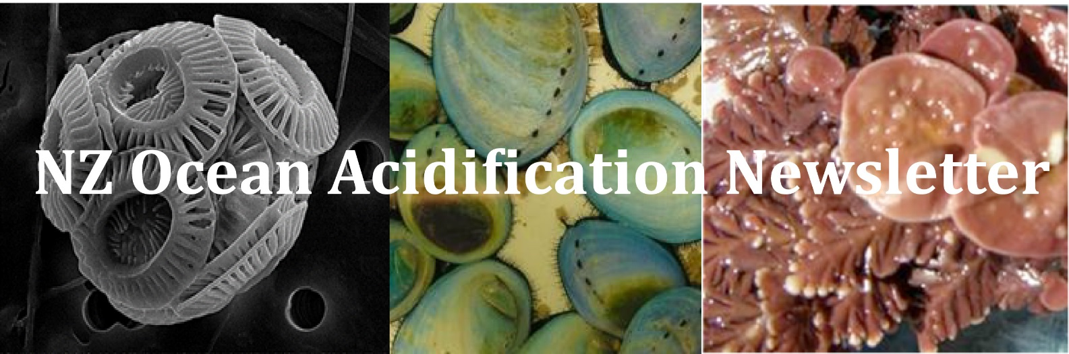

News
We had some feedback after the last newsletter asking for more information about the OA Alliance. Below is some more information of what NZOA has signed up for from NZOAC Christina McGraw.
Christina McGraw and Emily Frost attended the July 20th on-line meeting of the OA Alliance (https://www.oaalliance.org/). The OA Alliance has grown from 5 founding members in 2016 to 45 members today (NZOAC joined in July). Although initially funded by the funded Pacific Coast Collaborative - comprised of the U.S. States of California, Oregon, Washington and British Columbia Canada – the OA Alliance is now financially supported by several foundations including the Rockefeller Brothers Fund, the Sant Foundation, and Resources Legacy Fund. With this growth, the OA Alliance is also restructuring their governance. The Board of Directors (made up from representatives from Pacific Coast Collaborative), is being replaced by a Steering Committee with broader representation.
As an Affiliate Member, the NZOAC will work with OA Alliance and other Affiliate Members to create an individual plan that supports the OA Alliance goals, but is relevant to New Zealand and our community’s interests and expertise. For example, NZOAC members are already contributing to many of the Alliance goals, including advancing scientific understanding and expanding public awareness. The NZOAC Council will discuss the NZOAC plan at the September meeting. If you have ideas or suggestions, please contact Christina McGraw (christina.mcgraw@otago.ac.nz).

CARIM update (Vic Metcalf)
In July, hundreds of students from across New Zealand attended the annual two-day INSPIRE Festival in Nelson, run by the Ministry of Inspiration. This festival focuses on hands-on exposure to STEAM activities. CARIM was represented there for the second year running by myself (Victoria Metcalf, RA7 leader - outreach) and Norman Ragg (RA5 leader – shellfish experiments). We presented four workshops to more than 100 enthusiastic students on ocean acidification and pH. We invited them to join us as superhero scientists in training and help us better understand ocean acidification. Participants got to first hear about how Norman and myself became marine biologists. Then they were introduced to various oceanic threats including climate change’s ‘evil twin’, ocean acidification, via this easy to understand cartoon (view here).
We then moved on to exploring their understanding of pH and how it is measured. To do this, Norman had boiled up a red cabbage and strained off the juice. This purplish stinky solution is actually an amazing pH indicator, changing colour depending on what solutions are added. We had a number of different solutions (lemon juice, water, milk, vinegar, detergent in water, washing powder dissolved in water, and Coke) that they then added to the red cabbage dye to see if it changed colour. Acids produced a pink colour and alkaline solutions made it go purple or green or even a glowing blue. Having used this crude measure of pH, we introduced the concept of more precision, as well as variability and statistics. They were given strips of pH paper and shown pH meters. Now that they understood the concept of pH, we charged our superhero scientists in training with creating a miniature ocean acidification scenario using a Sodastream and a bottle of seawater. They had to measure the pH of the seawater and then gently (in most cases!) infuse it with CO₂ using the Sodastream and measure the change.
We then showed them that the pH of the sea around New Zealand is changing and that research in CARIM is trying to better understand this. We gave a brief overview of what we are looking at in CARIM and Norman talked them through some of the Cawthron Institute Greenshell Mussel work on breeding families to be more resistant to the impacts of ocean acidification. They also had a chance to look at shells from ocean acidification experiments on paua and see if they could identify which ones were the controls and which ones had been exposed to lower pH (pCO₂) conditions.
The feedback we had was that many said this was the best thing they did at INSPIRE. The methods will shortly be available on the CARIM website (www.carim.nz). Christina Armstrong from Cawthron Institute has been giving a similar module to many Nelson classes over the last year and again this year, contributing to RA7 outreach for CARIM.
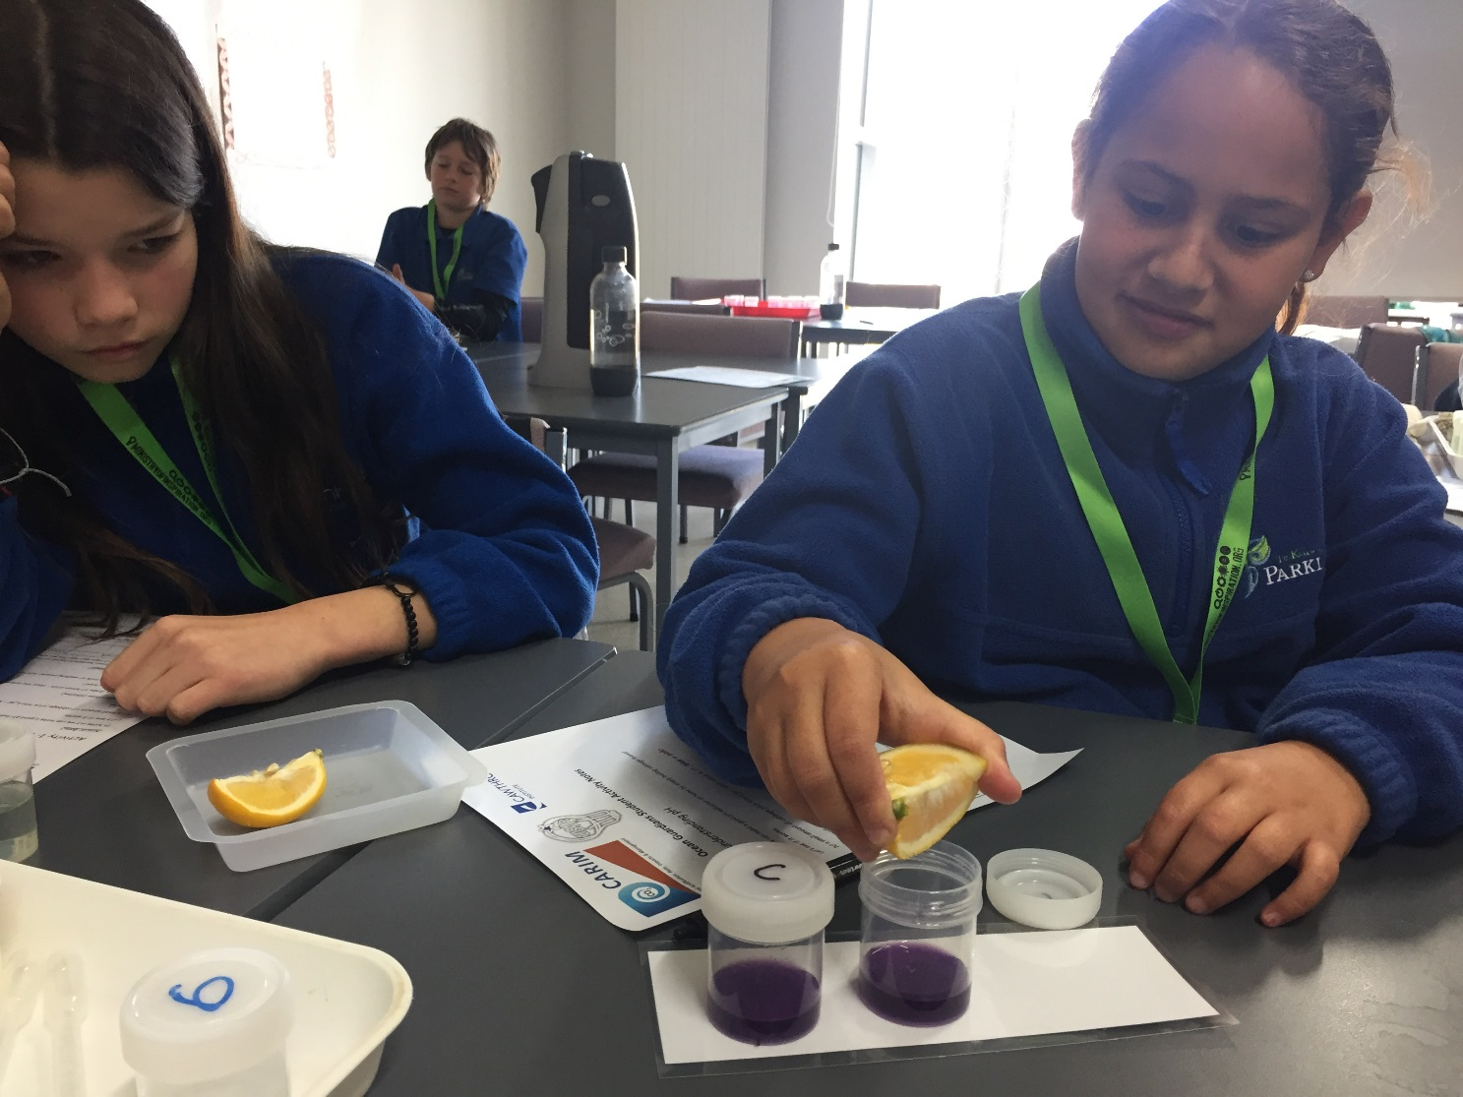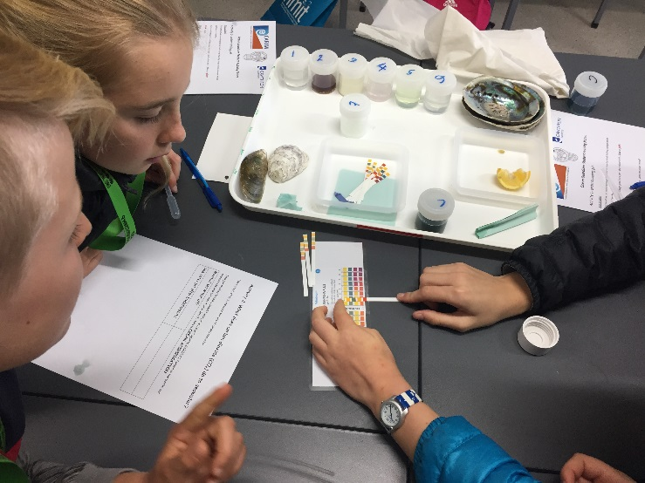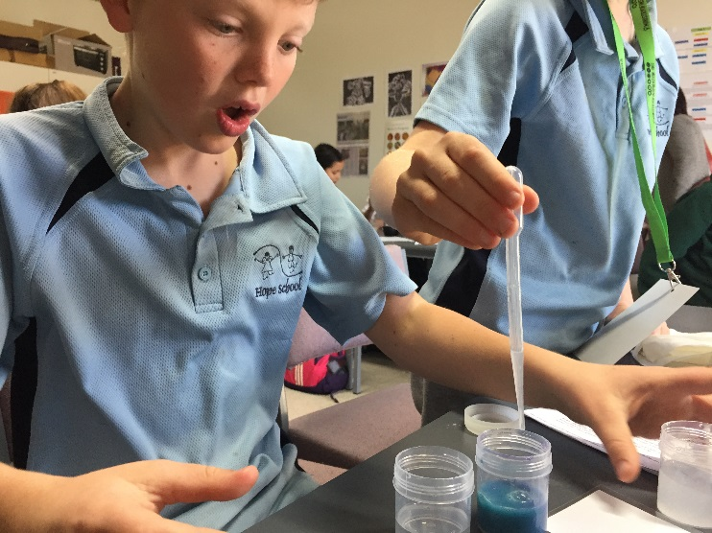
Our other key RA7 - Outreach activities aside from the website and these workshops also include:
- Facebook
- Twitter

Selection of reports, theses and recent papers from the SW Pacific
Ocean acidification of a coastal Antarctic marine microbial community reveals a critical threshold for CO2 tolerance in phytoplankton productivity. High-latitude oceans are anticipated to be some of the first regions affected by ocean acidification. Despite this, the effect of ocean acidification on natural communities of Antarctic marine microbes is still not well understood. In this study we exposed an early spring, coastal marine microbial community in Prydz Bay to CO2 levels ranging from ambient (343 μatm) to 1641 μatm in six 650 l minicosms. Productivity assays were performed to identify whether a CO2 threshold existed that led to a decline in primary productivity, bacterial productivity, and the accumulation of Chlorophyll a (Chl a) and particulate organic matter (POM) in the minicosms. In addition, photophysiological measurements were performed to identify possible mechanisms driving changes in the phytoplankton community. A critical threshold for tolerance to ocean acidification was identified in the phytoplankton community between 953 and 1140 μatm. CO2 levels ≥ 1140 μatm negatively affected photosynthetic performance and Chl a-normalised primary productivity (csPP14C), causing significant reductions in gross primary production (GPP14C), Chl a accumulation, nutrient uptake, and POM production. However, there was no effect of CO2 on C : N ratios. Over time, the phytoplankton community acclimated to high CO2 conditions, showing a down-regulation of carbon concentrating mechanisms (CCMs) and likely adjusting other intracellular processes. Bacterial abundance initially increased in CO2 treatments ≥ 953 μatm (days 3–5), yet gross bacterial production (GBP14C) remained unchanged and cell-specific bacterial productivity (csBP14C) was reduced. Towards the end of experiment, GBP14C and csBP14C markedly increased across all treatments regardless of CO2 availability. This coincided with increased organic matter availability (POC and PON) combined with improved efficiency of carbon uptake. Such changes in phytoplankton community production could have negative effects on the Antarctic food web and the biological pump, resulting in negative feedbacks on anthropogenic CO2 uptake. Increases in bacterial abundance under high CO2 conditions may also increase the efficiency of the microbial loop, resulting in increased organic matter remineralisation and further declines in carbon sequestration. Deppeler S., et al., 2017. Biogeosciences Discussions 1-36. Article.
Time series pCO2 at a coastal mooring: internal consistency, seasonal cycles, and interannual variability. Marine carbonate system monitoring programs often consist of multiple observational methods that include underway cruise data, moored autonomous time series, and discrete water bottle samples. Monitored parameters include all, or some of the following: partial pressure of CO2 of the water (pCO2w) and air, dissolved inorganic carbon (DIC), total alkalinity (TA), and pH. Any combination of at least two of the aforementioned parameters can be used to calculate the others. In this study at the Gray’s Reef (GR) mooring in the South Atlantic Bight (SAB) we: examine the internal consistency of pCO2wfrom underway cruise, moored autonomous time series, and calculated from bottle samples (DIC-TA pairing); describe the seasonal to interannual pCO2w time series variability and air-sea flux (FCO2), as well as describe the potential sources of pCO2wvariability; and determine the source/sink for atmospheric pCO2. Over the ~8.5 years of GR mooring time series, mooring-underway and mooring-bottle calculated-pCO2wstrongly correlate with r-values > 0.90. pCO2w and FCO2 time series follow seasonal thermal patterns; however, seasonal non-thermal processes, such as terrestrial export, net biological production, and air-sea exchange also influence variability. The linear slope of time series pCO2w increases by 5.2±1.4 µatm y−1 with FCO2 increasing 51 to 70 mmol m−2 y−1. The net FCO2 sign can switch interannually with the magnitude varying greatly. Non-thermal pCO2w is also increasing over the time series, likely indicating that terrestrial export and net biological processes drive the long term pCO2w increase. Reimer J. J., et al., Continental Shelf Research. Article (subscription required).
The Solomon Sea: its circulation, chemistry, geochemistry and biology explored during two oceanographic cruises. The semi-enclosed Solomon Sea in the southwestern tropical Pacific is on the pathway of a major oceanic circuit connecting the subtropics to the equator via energetic western boundary currents. Waters transiting through this area replenish the Pacific Warm Pool and ultimately feed the equatorial current system, in particular the equatorial undercurrent. In addition to dynamical transformations, water masses undergo nutrient and micronutrient enrichment when coming in contact with the coasts, impacting the productivity of the downstream equatorial region. Broadscale observing systems are not well suited for describing the fine-scale currents and water masses properties in the Solomon Sea, leaving it relatively unexplored. Two multidisciplinary oceanographic cruises were conducted in the Solomon Sea region, the first in July–August 2012 and the second in March 2014, by investigators from France and the United States. The experimental approach combined physical, chemical, geochemical and biogeochemical analyses, providing access to a wide range of space and time scales of the circulation. This collection of data allows describing the fine-scale structure of the currents and the water properties, transformations and mixing from the surface to the sill depth in the Solomon Sea and in the straits connecting it to the equator. Ocean-margin exchanges were documented through a comprehensive sampling of trace elements and isotopes as efficient tracers of natural fertilization processes. As air chemistry is largely impacted by the regional volcanic plumes, rainwater pH was also sampled. Dinitrogen fixation rates were measured and found to be among the highest in the global ocean, highlighting this region as a hot spot of nitrogen fixation. This study provides an overview of the climatic context during both cruises and the physical circulation and water masses properties. It provides a comprehensive description of all measurements made onboard, and presents preliminary results, aiming to serve as a reference for further physical, geochemical and biogeochemical studies. Ganachaud A., et al., 2017. Elementa: Science of the Anthropocene 5:33. Article.
Conceptualizing ecosystem tipping points within a physiological framework. Connecting the nonlinear and often counterintuitive physiological effects of multiple environmental drivers to the emergent impacts on ecosystems is a fundamental challenge. Unfortunately, the disconnect between the way “stressors” (e.g., warming) is considered in organismal (physiological) and ecological (community) contexts continues to hamper progress. Environmental drivers typically elicit biphasic physiological responses, where performance declines at levels above and below some optimum. It is also well understood that species exhibit highly variable response surfaces to these changes so that the optimum level of any environmental driver can vary among interacting species. Thus, species interactions are unlikely to go unaltered under environmental change. However, while these nonlinear, species-specific physiological relationships between environment and performance appear to be general, rarely are they incorporated into predictions of ecological tipping points. Instead, most ecosystem-level studies focus on varying levels of “stress” and frequently assume that any deviation from “normal” environmental conditions has similar effects, albeit with different magnitudes, on all of the species within a community. We consider a framework that realigns the positive and negative physiological effects of changes in climatic and nonclimatic drivers with indirect ecological responses. Using a series of simple models based on direct physiological responses to temperature and ocean pCO2, we explore how variation in environment-performance relationships among primary producers and consumers translates into community-level effects via trophic interactions. These models show that even in the absence of direct mortality, mismatched responses resulting from often subtle changes in the physical environment can lead to substantial ecosystem-level change. Harley C. D. G., et al., 2017. Ecology and Evolution 00:1–11. Article.
Species interactions drive fish biodiversity loss in a high-CO2 world. Accelerating climate change is eroding the functioning and stability of ecosystems by weakening the interactions among species that stabilize biological communities against change [1]. A key challenge to forecasting the future of ecosystems centers on how to extrapolate results from short-term, single-species studies to community-level responses that are mediated by key mechanisms such as competition, resource availability (bottom-up control), and predation (top-down control) [2]. We used CO₂ vents as potential analogs of ocean acidification combined with in situ experiments to test current predictions of fish biodiversity loss and community change due to elevated CO₂ [3] and to elucidate the potential mechanisms that drive such change. We show that high risk-taking behavior and competitive strength, combined with resource enrichment and collapse of predator populations, fostered already common species, enabling them to double their populations under acidified conditions. However, the release of these competitive dominants from predator control led to suppression of less common and subordinate competitors that did not benefit from resource enrichment and reduced predation. As a result, local biodiversity was lost and novel fish community compositions were created under elevated CO₂. Our study identifies the species interactions most affected by ocean acidification, revealing potential sources of natural selection. We also reveal how diminished predator abundances can have cascading effects on local species diversity, mediated by complex species interactions. Reduced overfishing of predators could therefore act as a key action to stall diversity loss and ecosystem change in a high-CO₂ world. Nagelkerken I., et al., Current Biology. Article (subscription required).
Effects of hypoxia and ocean acidification on the upper thermal niche boundaries of coral reef fishes. Rising ocean temperatures are predicted to cause a poleward shift in the distribution of marine fishes occupying the extent of latitudes tolerable within their thermal range boundaries. A prevailing theory suggests that the upper thermal limits of fishes are constrained by hypoxia and ocean acidification. However, some eurythermal fish species do not conform to this theory, and maintain their upper thermal limits in hypoxia. Here we determine if the same is true for stenothermal species. In three coral reef fish species we tested the effect of hypoxia on upper thermal limits, measured as critical thermal maximum (CT_{max}). In one of these species we also quantified the effect of hypoxia on oxygen supply capacity, measured as aerobic scope (AS). In this species we also tested the effect of elevated CO₂ (simulated ocean acidification) on the hypoxia sensitivity of CT_{max}. We found that CT_{max} was unaffected by progressive hypoxia down to approximately 35 mmHg, despite a substantial hypoxia-induced reduction in AS. Below approximately 35 mmHg, CT_{max} declined sharply with water oxygen tension (P_{w}O₂). Furthermore, the hypoxia sensitivity of CT_{max} was unaffected by elevated CO₂. Our findings show that moderate hypoxia and ocean acidification do not constrain the upper thermal limits of these tropical, stenothermal fishes. Ern R., et al., Biology Letters. Article (subscription required).
Long-term exposure to elevated carbon dioxide does not alter activity levels of a coral reef fish in response to predator chemical cues. Levels of dissolved carbon dioxide (CO₂) projected to occur in the world’s oceans in the near future have been reported to increase swimming activity and impair predator recognition in coral reef fishes. These behavioral alterations would be expected to have dramatic effects on survival and community dynamics in marine ecosystems in the future. To investigate the universality and replicability of these observations, we used juvenile spiny chromis damselfish (Acanthochromis polyacanthus) to examine the effects of long-term CO₂ exposure on routine activity and the behavioral response to the chemical cues of a predator (Cephalopholis urodeta). Commencing at ~3–20 days post-hatch, juvenile damselfish were exposed to present-day CO₂ levels (~420 μatm) or to levels forecasted for the year 2100 (~1000 μatm) for 3 months of their development. Thereafter, we assessed routine activity before and after injections of seawater (sham injection, control) or seawater-containing predator chemical cues. There was no effect of CO₂ treatment on routine activity levels before or after the injections. All fish decreased their swimming activity following the predator cue injection but not following the sham injection, regardless of CO₂ treatment. Our results corroborate findings from a growing number of studies reporting limited or no behavioral responses of fishes to elevated CO₂. Sundin J., et al., 2017. Behaviorial Ecology and Sociobiology 71: 108. doi:10.1007/s00265-017-2337-x. Article.
Defying dissolution: discovery of deep-sea scleractinian coral reefs in the North Pacific. Deep-sea scleractinian coral reefs are protected ecologically and biologically significant areas that support global fisheries. The absence of observations of deep-sea scleractinian reefs in the Central and Northeast Pacific, combined with the shallow aragonite saturation horizon (ASH) and high carbonate dissolution rates there, fueled the hypothesis that reef formation in the North Pacific was improbable. Despite this, we report the discovery of live scleractinian reefs on six seamounts of the Northwestern Hawaiian Islands and Emperor Seamount Chain at depths of 535–732 m and aragonite saturation state (Ω_{arag}) values of 0.71–1.33. Although the ASH becomes deeper moving northwest along the chains, the depth distribution of the reefs becomes shallower, suggesting the ASH is having little influence on their distribution. Higher chlorophyll moving to the northwest may partially explain the geographic distribution of the reefs. Principle Components Analysis suggests that currents are also an important factor in their distribution, but neither chlorophyll nor the available current data can explain the unexpected depth distribution. Further environmental data is needed to elucidate the reason for the distribution of these reefs. The discovery of reef-forming scleractinians in this region is of concern because a number of the sites occur on seamounts with active trawl fisheries. Baco A. R., et al.,2017. Scientific Reports 7: 5436. doi:10.1038/s41598-017-05492-w. Article.
Predation in high CO2 waters: prey fish from high-risk environments are less susceptible to ocean acidification. Most studies investigating the effects of anthropogenic environmental stressors do so in conditions that are often optimal for their test subjects, ignoring natural stressors such as competition or predation. As such, the quantitative results from such studies may often underestimate the lethality of certain toxic compounds. A well-known example of this concept is illustrated by the marked increase in the lethality of pesticides when larval amphibians are concurrently exposed to the odor of potential predators. Here, we investigated the interaction between background levels of environmental predation risk (high vs. low) and ocean acidification (ambient vs. elevated CO₂) in 2 × 2 design. Wild-caught juvenile damselfish, Pomacentrus amboinensis, were exposed in the laboratory to the different risk and CO₂ conditions for 4 days and released onto coral reef patches. Using a well-established field assay, we monitored the in situ behavior and mortality of the damselfish for 2 days. We predicted that juvenile fish exposed to elevated CO₂ and high-risk conditions would display more severe behavioral impairments and increased mortality compared to fish exposed to elevated CO₂ maintained under low-risk conditions. As expected, elevated CO₂ exposure led to impaired antipredator responses and increased mortality in low-risk fish compared to ambient CO₂ controls. However, we failed to find an effect of elevated CO₂ on the behavior and survival of the high-risk fish. We hypothesized that the results may stem from either a behavioral compensation or a physiological response to high risk. Our results provide insights into the interactive nature of environmental and natural stressors and advance our understanding of the predicted effect of ocean acidification on aquatic ecosystems. Ferrari M. C. O., et al., Integrative and Comparative Biology. Article (subscription required).
Ocean acidification narrows the acute thermal and salinity tolerance of the Sydney rock oyster Saccostrea glomerata. Coastal and estuarine environments are characterised by acute changes in temperature and salinity. Organisms living within these environments are adapted to withstand such changes, yet near-future ocean acidification (OA) may challenge their physiological capacity to respond. We tested the impact of CO2-induced OA on the acute thermal and salinity tolerance, energy metabolism and acid-base regulation capacity of the oyster Saccostrea glomerata. Adult S. glomerata were acclimated to three CO2 levels (ambient 380 μatm, moderate 856 μatm, high 1500 μatm) for 5 weeks (24 °C, salinity 34.6) before being exposed to a series of acute temperature (15–33 °C) and salinity (34.2–20) treatments. Oysters acclimated to elevated CO2 showed a significant metabolic depression and extracellular acidosis with acute exposure to elevated temperature and reduced salinity, especially at the highest CO2 of 1500 μatm. Our results suggest that the acute thermal and salinity tolerance of S. glomerata and thus its distribution will reduce as OA continues to worsen. Parker L. M., et al., Marine Pollution Bulletin. Article (subscription required).
Iron sources alter the response of Southern Ocean phytoplankton to ocean acidification. The rise in anthropogenic CO2 and the associated ocean acidification (OA) will change trace metal solubility and speciation, potentially altering Southern Ocean (SO) phytoplankton productivity and species composition. As iron (Fe) sources are important determinants of Fe bioavailability, we assessed the effect of Fe-laden dust versus inorganic Fe (FeCl3) enrichment under ambient and high pCO2 levels (390 and 900 μatm) in a naturally Fe-limited SO phytoplankton community. Despite similar Fe chemical speciation and net particulate organic carbon (POC) production rates, CO2-dependent species shifts were controlled by Fe sources. Final phytoplankton communities of both control and dust treatments were dominated by the same species, with an OA-dependent shift from the diatom Pseudo nitzschia prolongatoides towards the prymnesiophyte Phaeocystis antarctica. Addition of FeCl3 resulted in high abundances of Nitzschia lecointei and Chaetoceros neogracilis under ambient and high pCO2, respectively. These findings reveal that both the characterization of the phytoplankton community at the species level and the use of natural Fe sources are essential for a realistic projection of the biological carbon pump in the Fe-limited pelagic SO under OA. As dust deposition represents a more realistic scenario for the Fe-limited pelagic SO under OA, unaffected net POC production and dominance of P. antarctica can potentially weaken the export of carbon and silica in the future. Trimborn S., et al., Marine Ecology Progress Series. Article (prepress abstract).
Altered sediment biota and lagoon habitat carbonate dynamics due to sea cucumber bioturbation in a high-pCO2 environment. The effects of global change on biological systems and functioning are already measureable, but how ecological interactions are being altered is poorly understood. Ecosystem resilience is strengthened by ecological functionality, which depends on trophic interactions between key species and resilience generated through biogenic buffering. Climate-driven alterations to coral reef metabolism, structural complexity and biodiversity are well documented, but the feedbacks between ocean change and trophic interactions of non-coral invertebrates are understudied. Sea cucumbers, some of the largest benthic inhabitants of tropical lagoon systems, can influence diel changes in reef carbonate dynamics. Whether they have the potential to exacerbate or buffer ocean acidification over diel cycles depends on their relative production of total alkalinity (AT) through the dissolution of ingested calcium carbonate (CaCO₃) sediments and release of dissolved inorganic carbon (CT) through respiration and trophic interactions. In this study, the potential for the sea cucumber, Stichopus herrmanni, a bêche-de-mer (fished) species listed as vulnerable to extinction, to buffer the impacts of ocean acidification on reef carbonate chemistry was investigated in lagoon sediment mesocosms across diel cycles. Stichopus herrmanni directly reduced the abundance of meiofauna and benthic primary producers through its deposit-feeding activity under present-day and near-future pCO2. These changes in benthic community structure, as well as AT (sediment dissolution) and CT (respiration) production by S. herrmanni, played a significant role in modifying seawater carbonate dynamics night and day. This previously unappreciated role of tropical sea cucumbers, in support of ecosystem resilience in the face of global change, is an important consideration with respect to the bêche-de-mer trade to ensure sea cucumber populations are sustained in a future ocean. Wolfe K., et al.,. Global Change Biology. Article (subscription required).

Upcoming meetings
AGU Ocean Sciences meeting 11-16th February 2018, Portland, Oregon.
Abstracts closing 6th September. Lots of sessions involving topics related to Ocean Acidification.
http://osm.agu.org/2018/

